**Website Inspirations:**

In the initial design process, I reviewed some designs that I believe would be appropriate for the task I was required to do, and looked into some designs that I believed to be aesthetically pleasing.

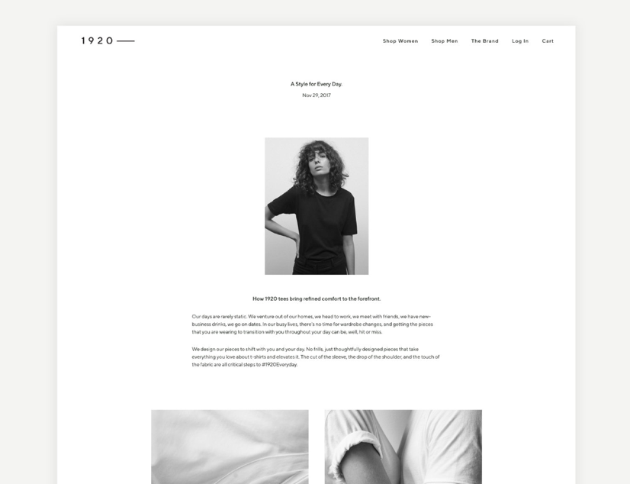

I admire the design on the right because it is minimalistic and black and white (Ivansson, 2019)

. With the heavy content load I was given in regards to the task. A design similar to the one above would be perfect. Overall the simplicity of the design is what drew me in, however, this is also one of the designs downfalls. The above design has a very simplistic navigation bar. Something that I believe could be worked on. After looking at other website examples, I believe that a large navigation bar or hero image would be better suited for the type of site I wanted to design. Below is a design that I drew a lot of inspiration from in regards to designing a hero image:

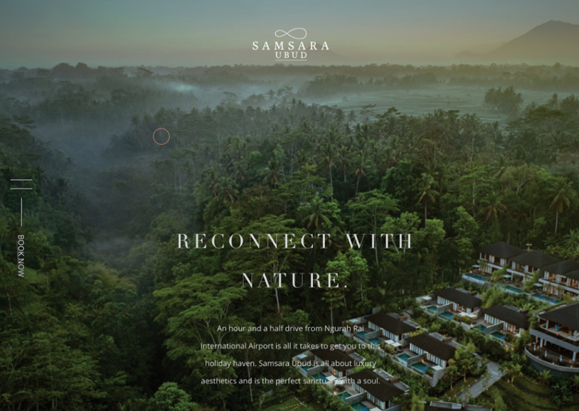The design on the left was heavily focused on the image elements within the site (Samsaraubud.com, 2019). I believe this is a good way creating a accessible site and it can be easily read and navigated using images. The overall aesthetic elements of the above site are inspiring, as they are very simplistic and minimalistic. However, there are evident issues with the above site that I believe would be troublesome when trying to make the site responsive. Due to the heavy focus on images, the site takes a long time to load and often glitches. The aesthetic side of the site is inspiring, however, due to the heavy content load on my own site, the glitches from the images and effects would be troublesome in the usability and accessibility of my own site.

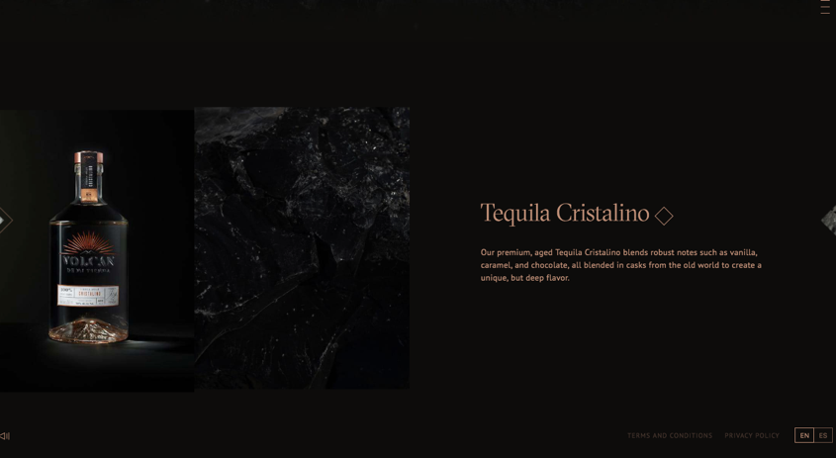The inspirations I took from the design on the right were the elements related to the coloring of the site (Volcan.com, 2019). In regards to the content of my own site in developed an understanding of what would be best suited for the type of siting I am trying to achieve. As it is a site related to heritage and conservation I believed that the colors should be muted and slightly ‘old-fashioned’. I don’t want my design too be too bright and distracting from the websites content. I read many articles stating that the content should not be too ‘visually complex’ and as a result a simplistic design was what I decided on (Walker, 2013). The statement ‘less is more’ was very evident through my research (Smith, 2016). The colors I ended up choosing were in relation to the heritage idea surrounding the content of my website. I believe the above website does this successfully.

**Helpful Resources:**

Washington.edu. (2019). *Developing Accessible Websites | Accessible Technology*. [online] Available at: http://www.washington.edu/accessibility/web/ [Accessed 6 May 2019].

The above website was helpful during the accessibility element of this project. It detailed the necessary components and procedures that need to be completed in order to successfully test the accessibility of my design. It did this by providing the appropriate websites needed to test html and WCAG.

Wuhcag. (2019). *WCAG 2.0 checklist - a free and simple guide to WCAG 2.0*. [online] Available at: https://www.wuhcag.com/wcag-checklist/ [Accessed 7 May 2019].

The above site was also used a lot in my development of this project. It helped broaden my understanding of accessibility and the procedures that need to be done to test accessibility. Even though the site may have been too detailed it definitely gave me a deeper understanding.

Awwwards.com. (2019). *Awwwards - Website Awards - Best Web Design Trends*. [online] Available at: https://www.awwwards.com/ [Accessed 7 May 2019].

The Awwards website was where I found most of my design inspiration. It gave highly detailed and professional designs that inspired a lot of my work.

**Wireframes:**

Overall the approaches that guided my design decisions were focused on minimalism and accessibility. These two elements were what I hoped to achieve in the final project. There are multiple elements within my project that I believe help to reinforce the overall approach of my design. Below are the original wireframes I designed for this project. The text I chose reflected the content successfully as I believe that it is minimalistic as well as ‘old-fashioned’. The colors chosen help with the accessible element of the project as they are simple and read easily.

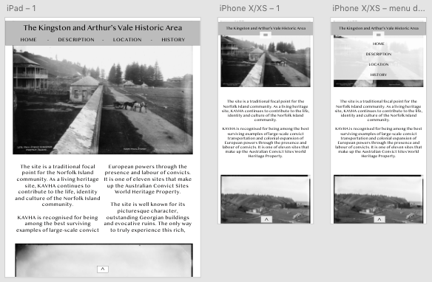Design One:

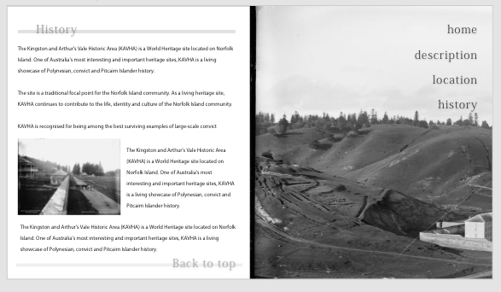

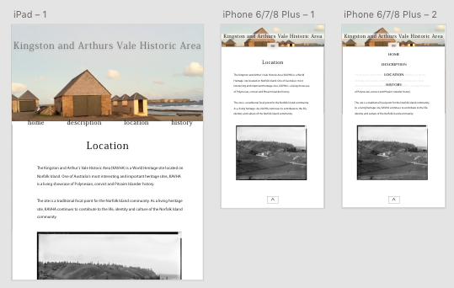Design Two:

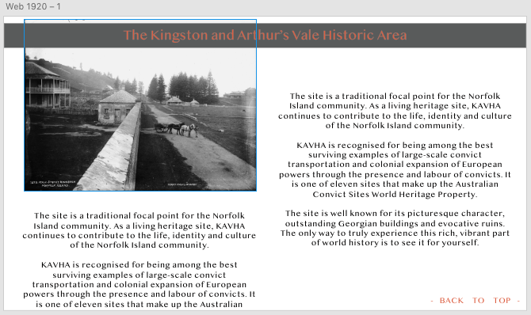

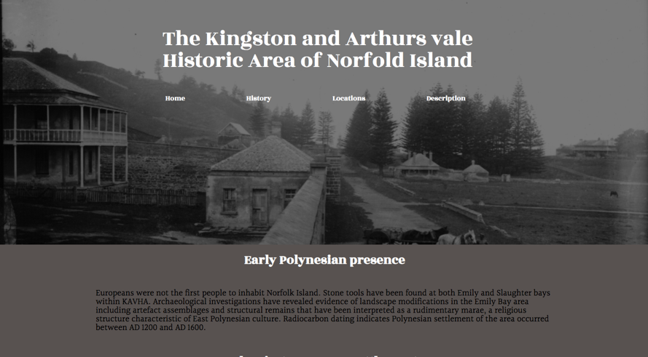After playing around with the wireframes and placing them within css I found that the designs were too simplistic. I wanted to create a bigger impact with my hero image therefore I found a website that enabled me to create a hero image similar to that of the ‘Samsara’ website above.

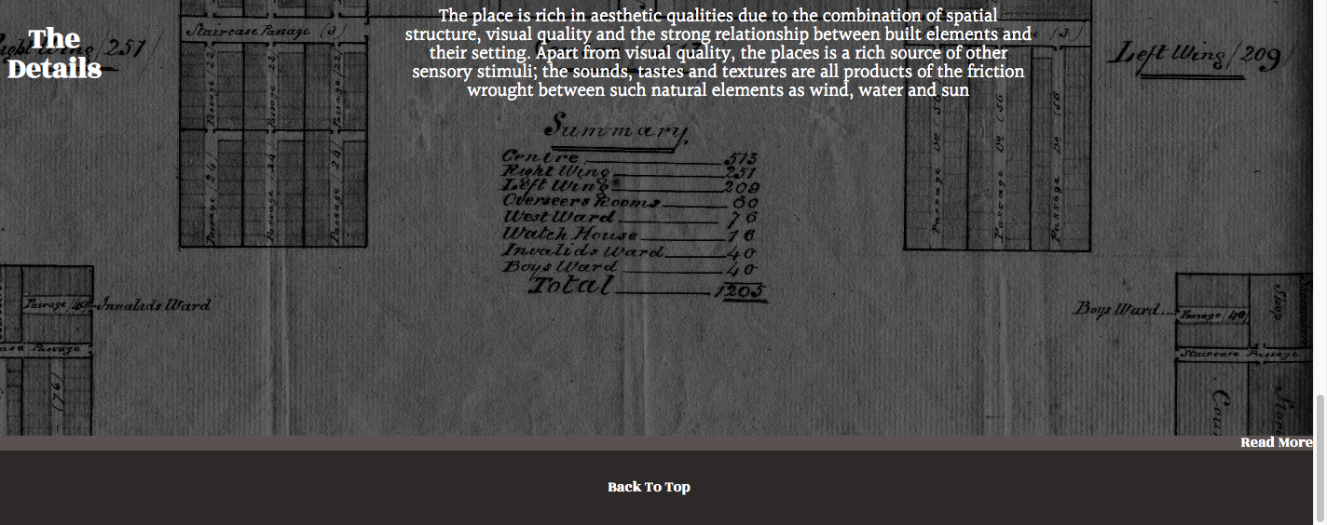At this point my website had the basic elements I wanted to include within my site. It included a large hero image and minimalistic one column paragraphs, however, I wanted to extend the overall aesthetic element of the site and include some more advanced CSS elements. I then decided to include some image elements to the index page and more links to the other pages as a way to make the website more creative. It was here I struggled with the text elements over the images, as you can see in the below image. The link would continue to go underneath the image element and the title

In order to fix this design problem I have to change the padding and margins of the text and links on the image. Once doing so all of the elements were able to fit on the image however I came to the conclusion that there were too many elements on top of the image so I decided to simplify it by removing the title. Below is the final design I came up with.

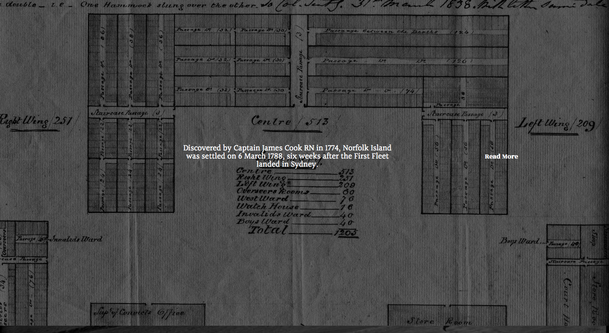

The next element that I struggled with was in regards to the responsiveness of the website. When moving from the browser view to tablet the borders wouldn’t move. I discovered that this was a result of the h2 and h1 elements and their width. I discovered I was using vm which was a unit that doesn’t actually exist. In order to fix the responsiveness I changed the sizing of the widths to percentages and vw/vh/vmin elements.

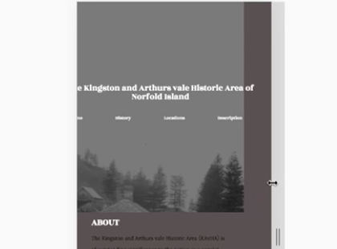

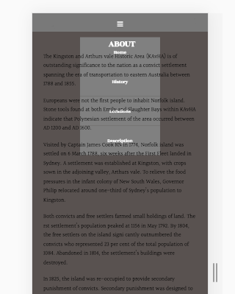In order to add an a additional responsive element to my website, I decided to add a hamburger element as navigation when transferring to mobile view. I found a video that enabled me to achieve this element however, when actually transferring to mobile mode I found that the toggle element was moving across the screen whenever I interacted with it. I fixed this by using the element known as: {text-align: centre}. The next issue was also in regards to the hamburger element. Whenever I tried to move onto a link it was difficult because the links were underneath the text of the website. I fixed this by using the z-index element which enabled me to layer the elements on top of one another.

**Accessibility Audit**

The importance of accessibility within a website is one of the key elements in creating a successful website. People with disabilities, whether temporary or permanent, should be able to access the internet and information the same as people without disabilities. By using the WCAG 2.0 checklist, websites are able to follow the guidelines of an accessible website that is enforced by the Australian Government. Accessibility gives all people equal access and opportunity.

1. Perceivable

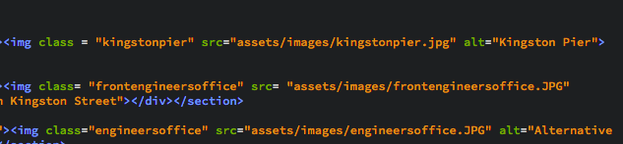**1.1: Non-Text Content:**

* The header images are purely decorative and according to the WCAG 2.0 checklist they do not need a description.
* I found that the images not used for decorative purposes did not have alternative descriptions for people unable to see. Therefore I added descriptions of the images using the alt=” “ tag. ^

**1.3.1: Info and Relationships:**

* The sections and content is labeled correctly using headings and subheadings, making the content of the website easier to understand for people with disabilities. There is evident clear labeling.

**1.3.2: Meaningful Sequence:**

* 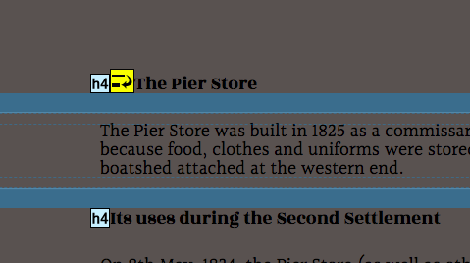The content is presented in a meaningful order, this was checked using the W3C HTML validator. Initially the title sequence was a h1 element, this disrupted the flow of the website so I changed the title to a h2 element and this fixed the problem.
* There was also a problem with skipping the h3 element on the location page so I added a dummy h3 element before the initial h4 element, in order to correct the flow. >

**1.4.1: Use of Color:**

* The website was printed in black and white and I found that people with some degree of colour blindness would struggle to read the website. In order to fix this element I increased the brightness of the text.

**1.4.2: Audio Control:**

* Non- Applicable

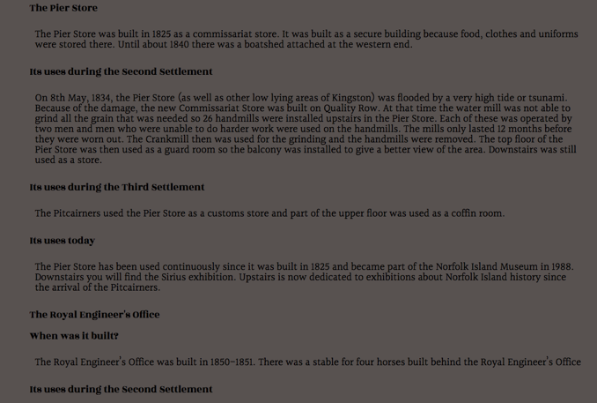**1.4.3: Contrast (Minimum):**

* White on a dark background is a good contrast.

**1.4.4: Resize Text:**

* The text is responsive on all platforms

**1.4.5: Images of Text:**

* Text is used as navigation therefore every page is recognizable and legible.

2. Operable

**2.1.1: Keyboard Accessible:**

* Navigation using a keyboard within the site is easy. This is evident within the clean html and css found from the validators.

**2.1.2: No Keyboard Trap:**

* Passed. The website does not trap the user if they are only using a keyboard.

**2.3.1: Three Flashes or Below:**

* Non-Applicable

**2.4.1: Bypass Blocks:**

* There are ‘skip to content’ links within the website, as well as at the bottom of the page where it allows the user to skip to the top of the page.

**2.4.2: Page Titled:**

* Each page is correctly labelled.

**2.4.3: Focus Order:**

* There is evident meaning behind the page order that allows the user to understand the information correctly and easily.

**2.4.4: Link Purpose (In Context):**

* All links are correctly labelled or are titled ‘read more’ once the user has read the introduction to the information.

**2.4.5: Multiple Ways:**

* Evident within the index page

**2.4.6: Headings and Labels:**

* Passed, headings and labels describe the topic to come after them.

3. Understandable

**3.1.2: Language of Page:**

* Each page has English assigned to it.

**3.2.3: Consistent Navigation:**

* The navigation is consistent throughout the whole website, as a result of the header and footer links.

**3.2.4: Consistent Identification:**

* Consistent throughout all text and images.

4. Robust

**4.1.1: Parsing:**

* Full content tags, passed.

**References:**

Ivansson, E. (2019). *1920 — Emelie Ivansson*. [online] Emelie Ivansson. Available at: https://www.emelieivansson.com/1920everyday [Accessed 13 Mar. 2019].

Samsaraubud.com. (2019). *Samsara Ubud Resort | A Luxury Villa Resort in Ubud Bali*. [online] Available at: https://www.samsaraubud.com/ [Accessed 7 May 2019].

Smith, A. (2016). *Less Is Still More: The Importance Of The Minimalist Approach To Web Design - Usability Geek*. [online] Usability Geek. Available at: https://usabilitygeek.com/less-is-more-importance-minimalist-web-design/ [Accessed 8 Mar. 2019].

Volcan.com. (2019). *Volcán Tequila*. [online] Available at: https://www.volcan.com/en/product/tequila-cristalino [Accessed 7 May 2019].

Walker, T. (2013). *Why "Simple" Websites Are Scientifically Better*. [online] CXL. Available at: <https://conversionxl.com/blog/why-simple-websites-are-sc>ientifically-better/ [Accessed 11 Mar. 2019].

Washington.edu. (2019). *Developing Accessible Websites | Accessible Technology*. [online] Available at: http://www.washington.edu/accessibility/web/ [Accessed 6 May 2019].

Wuhcag. (2019). *WCAG 2.0 checklist - a free and simple guide to WCAG 2.0*. [online] Available at: https://www.wuhcag.com/wcag-checklist/ [Accessed 7 May 2019].